|  |
| --- |
|  |

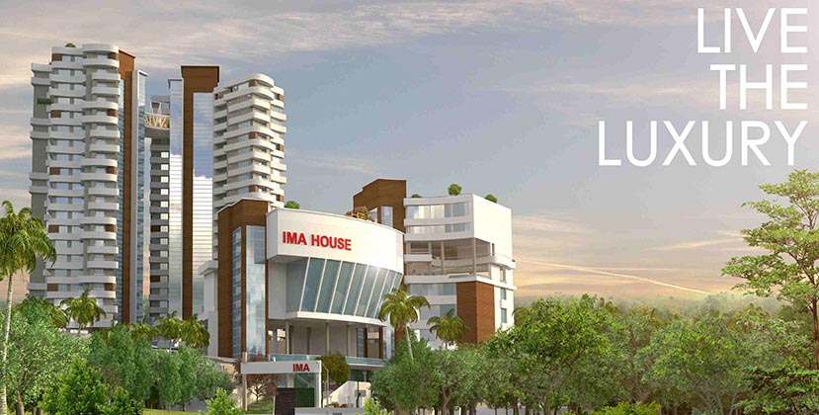

**DOCTORS ENCLAVE**

**MANJERI, MALAPPURAM, KERALA**

**Promoted By:**

IMA Welfare and Research Society,

672/13, IMA House, IMA Jn, Vayapparappady, Manjeri

Malappuram-676121

Phone: 7559836697

Mail id: [imasocietymanjeri@gmail.com](mailto:imasocietymanjeri@gmail.com)

Website :Imadoctorsenclave.com

[admin@imadoctorsenclave.com](mailto:admin@imadoctorsenclave.com)

**Project Management Consultants :**

Tree Engineering Consultants Pvt Ltd,

*ISO 9001:2015 Certified Project Management Company,*

Door No IV/991-A, Club Junction,

Edappally-24.

Phone: 0484-4300322/422/522

Mail id: [info@treeinco.com](mailto:info@treeinco.com)

**DOCTORS ENCLAVE**

**MANJERI, MALAPPURAM, KERALA**



**FEASIBILITY STUDY REPORT**

**SCENARIO**

Indian Medical Association is the largest professional organization in the world. Kerala State Branch is the most vibrant of all the state branches. IMA Kerala is host to a number of member friendly schemes to help their members and their families.

IMA Manjeri Branch is one among the most vibrant branches amongst all the 110 branches under the immediate apex body IMA Kerala. Monthly Meetings were held at the office premises or at suitable places depending upon the convenience of the members of the organisation to discuss and to try to find solutions for the requirements as well as grievances if any of the fellow members. Many such meetings had been conducted under the chairmanship of Dr Joy , Chairman of the branch along with other office bearers of IMA Manjeri Branch. The leadership was able to make the members deliberate on issues of common interest and take judicious decisions based on requirements and considering the opinion of the majority.

One of the major concerns raised during such a meeting was the requirement for a residential place for all the members as all the practicing members need to be located within the vicinity of the work place to meet any urgent requirements. This genuine requirement from the part of members was seriously considered and active interactive deliberations were carried out and as a result a decision was taken to construct a common apartment at a place which is convenient for all the members to commute to their respective work places.

Subject to the decision to construct a common residential area , it was decided to form a society to monitor the construction activities and related formalities. A society in the name and style of IMA Welfare And Research Society was formed and registered.

The above mentioned society identified a land to the extent of 43.35 cents at Narukara Village, Ernadu Thaluk, Malappuram to construct the residential complex for the members and proceeded to obtain the necessary approvals from the concerned regulators. The building permit and other approvals were being obtained.

**FURTHERENCE OF INITIAL PROPOSAL**

But owing to increased demand from the members in respect of units required the society had to consider about moving to an extended area so that the requirement of majority of the fellow members could be met. The society then decided to construct 118 apartments in 20 floors with sufficient car parking at a newly identified and purchased land.

As the consent in principle has been obtained from more than the proposed units to be constructed the commitment was restricted to 50 percent of the saleable area on a first come first served basis. The society is seeking an external financing to proceed the construction plan as designed initially so that rest of the units can also be sold at the earliest.

The List of hospitals in and around the proposed residential complex are as below

1. Govt Medical College Malappuram Manjeri  - 150 Doctors

2. General Hospital Malappuram -Manjeri -50 Doctors

3.        Korambayil Hospital & Diagnostic Centre (P) Ltd, Manjeri -  43 Doctors

4.        Malabar Hospital, Manjeri  - 23 Doctors

5.        Prasanthi Hitech Hospital, Manjeri  - 19 Doctors

6.        Manu Hospital, Manjeri- 33 Doctors

7.        Ernad Hospital, Manjeri -15 Doctors

8.        Tree Gee Eye Hospital, Manjeri  - 6 Doctors

9.        Ahalya Eye Hospital, Manjeri - 4 Doctors

In addition to this, a new  300 crore budgeted large superspecialty hospital by SamanaAppollo Group in middle east is coming at Manjeri. (Construction of the project is already underway and according to our information the Hospital will be functioning by 2020)

Another large super specialty hospital by Al-Abeer group is about to inaugurate is near Malappuram about 8km from Manjeri.

In addition to these there are Dental doctors and Eye specialists working in clinics and hospital at Manjeri and surrounding towns who might also be interested in the proposed residential complex

**CONCLUSION**

In the lights of the above facts the society is confident about the marketability and saleability of the units concerned. The society is also considering the enhancement of available facilities by constructing a club house for use of all members of the organisation. Also discussions are ongoing for similar other projects if the demand cannot be met from the first residential complex project

|  |
| --- |
|  |

INTRODUCTION

Indian Medical Association is the largest professional organization in the world. Kerala State Branch is the most vibrant of all the state branches. IMA Kerala is host to a number of member friendly schemes to help their members and their families.

IMA kerala has approximately 110 branches spread across the length and width of the state of Kerala. IMA Manjeri Branch is a vibrant branch amongst them. Manjeri is located in Malappuram District which has the highest population of approximately 41 Lacs and is considered to be a major hub for hospitals. The place already has seven private hospitals, one government hospital and the only Medical College in the district.

IMA Manjeri Branch has a strength of 174 doctors as its members who hail from both within the place, far off from the district and also from outside the district. Owing to the scarcity of dwelling place and the eagerness of the enthusiastic professional community to have a common dwelling place the members of the Manjei branch have taken a unanimous decision and expression of interest to construct a multi-storeyed apartment for the members (IMA Doctors Enclave). For the fulfilment of the same a society was formed in the name and style of IMA Welfare and Research Society for monitoring the construction and related aspects relating to successful completion of the project.

IMA Welfare and Research Society invited applications to appoint a Project Management Consultant for effectively completing the said project. After competitive bidding and presentations and further negotiations Tree Engineering Consultants Private Limited as the Project Management Consultants to efficiently utilise their expertise in construction segment.

Further applications were invited for finding a suitable architect and efficient contractor for the timely completion of the project under the supervision of PMC and M/s Prashant Associates & M/s Highlight Constructions Private Limited was appointed as the architect and contractor for execution of civil works associated with the project respectively

The society is looking for a bank finance support for the successful completion of the project with in the desired time limits without compromising on the quality.

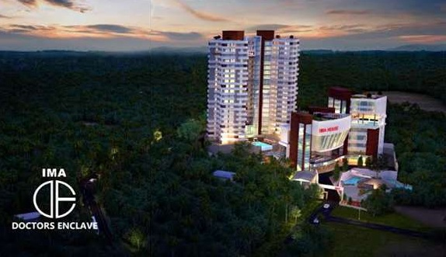

The project involves 2 BHK attached @ 1351sq.ft, 3 BHK attached @ 1635sq.ft to 2500sq.ft with all amenities

Doctors Enclave is exclusively for doctors of IMA as well as IDA

PROFILE OF PROMOTER

Name of the Society : IMA WELFARE AND RESEARCH SOCIETY, MANJERI

Registered Address : IMA WLFARE AND RESEARCH SOCIETY

Ima House, Ima Jn.

Vayapparappady,

Manjeri,

Malappuram District

Pin-676121

Office Address : 672/13, IMA House,

IMA HOUSE,IMAJn,

Vayapparappaady, Manjeri,

Malappuram – 676121

The Aims and Objects of the Society are:-

* To promote Social, Cultural and Professional activities of members of the society.
* To provide leadership and professional services in National Calamities and Epidemics occurring in the community.
* To provide residential spaces including essential amenities exclusively for modern medicine practising doctor. The ownership will be limited to modern medicine practising doctors and can be transferrable to their legal heirs. Final decision regarding the plan and possession of residential spaces and common amenities will be solely taken by the executive board.
* Doctors’ club house exclusively for those who subscribe the club membership.(Future Course)
* Recreational facilities for the members and their families (optional).
* Members will be provided reasonable recreational and health club facilities and academic spaces which may include libraries, internal facilities, meeting and seminar halls etc.
* To provide charitable services including medical relief, relief to the poor and unaffordable.
* To do all other acts and deeds which are incidental to the aims and objectives of the Society and to take up all other lawful activities for the attainment of the objectives listed above.
* The beneficiaries of the charitable services of the Society are persons residing in Malappuram District without considering caste, creed, religion, sex, colour, language or profession.
* The resources of the society will be utilised only for the objectives set out in the Memorandum of Association of the society.

**WHY MANJERI**

As mentioned earlier Manjeri is the largest densiliy populated area within the state of Kerala. The density of population itself is the main reason for Manjeri being the favourite professional hub for doctors and hospitals. Manjeri has recorded the highest birth rate in comparison with the overall average of the state. The density of population has also contributed to the higher ratio of diseases as well in the state. There is lot of potential for the practicing physicians and majority of the practitioners are natives of other parts of the state and country and who want to settle the rest of their life in Manjeri. The same has been the reason for big corporate giants and the government sector to establish multi-speciality hospitals in and around Manjeri.

The fact that majority of the modern medicine practitioners in Manjeri is from other parts of the state and country and they are quite interested to settle in Manjeri has actually contributed to considering a common dwelling place in Manjeri for the professional community. The selection of the location for the residential apartments was also considering the proximity to various hospitals which is mandated for the medical profession community. Accordingly acquisition of land was done over a period of 4 years . The same was purchased in bits and pieces and have now a vast area to the tune of 2.6 acres of land.

Also an important aspect for selection of the proposed area was the proximity to hospitals and the city centre. At the same time the locality is blessed with attractions like calm and quite area where the professional members would find it better after the professionally engaged hours. Also there is no further scope for other buildings to come closer to it as the surrounding lands are mostly held by NSS Trust.

The above mentioned facts have made manjeri a major hub for the medical practitioners. Major hospitals like Appolo have also shown interest in establishing a unit in and around Manjeri. Also several other major groups are establishing their hospitals whose completion are near by.

LOCATION

The proposed building “IMA-Doctors Enclave” will be at Kavalangad, Manjeri Village of Malappuram District, which is having more than five hospitals and number of clinical units.

**DOCTORS ENCLAVE**

**MANJERI, MALAPPURAM, KERALA**

